Research Report: Socio-Economic Factors and Health Outcomes
Abstract
This report investigates the correlation between key socio-economic factors and cancer mortality rates in the United States. Utilizing the “cancer_reg.csv” dataset, the analysis employs data cleaning, Exploratory Data Analysis (EDA), and data visualization techniques to address the research question: "How do socio-economic factors, including median household income and unemployment rate, correlate with the prevalence of chronic diseases across diverse counties in the United States?". The findings, derived from the Colab notebook, demonstrate a significant negative correlation between median income and cancer death rates, and a positive correlation between poverty rates and mortality. These insights underscore the profound impact of social determinants on public health outcomes.

1. Introduction
The prevalence of chronic diseases is a leading public health concern, with outcomes varying significantly across different populations. While clinical factors are crucial, socio-economic conditions, often termed social determinants of health, play a pivotal role in shaping community health profiles. Factors such as household income, poverty levels, and employment rates can influence everything from healthcare access and quality to environmental exposures and health behaviors. This study focuses on quantifying the relationship between these socio-economic indicators and cancer mortality rates, providing a data-driven look into health disparities at the county level in the United States.

2. Methodology
The analysis was conducted on the cancer_reg.csv dataset, following the complete workflow detailed in the Colab notebook: https://colab.research.google.com/drive/1Iud7S2sm4ZBpgBxW3ot2JCqi0qI1BSua?usp=sharing
The process involved three primary stages:
- Data Preparation: The dataset was loaded using the Pandas library. Initial data cleaning involved removing columns with a high volume of missing data and imputing null values for the employment percentage column (pctemployed16_over) using the median to preserve data integrity.
- Exploratory Data Analysis (EDA): A comprehensive EDA was performed to uncover patterns and relationships. This was achieved by generating a series of visualizations using the Matplotlib and Seaborn libraries to inspect variable distributions and correlations.
- Statistical Modeling: A Linear Regression model was implemented to further quantify the relationship between the selected socio-economic features (e.g., medincome, povertypercent) and the target variable (target_deathrate).

3. Results and Findings
The EDA process yielded several key visualizations that directly address the research question. The initial analysis focused on understanding the distribution of the core variables.
Figure 1: Distributions of Key Variables: The histograms reveal the statistical distributions of the cancer death rate, median household income, and poverty percentage. The cancer death rate approximates a normal distribution, while median income and poverty rates are right-skewed, indicating most counties fall into lower-to-mid ranges for these metrics.
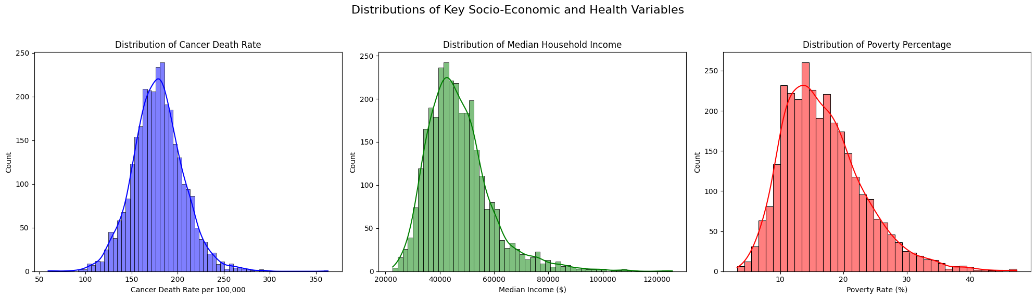
Figure 1: Distributions of Key Variables
To investigate the primary relationship between wealth and health outcomes, a regression plot was generated to compare median income directly against the cancer death rate.
Figure 2: Correlation between Median Income and Cancer Death Rate. This scatter plot clearly illustrates a negative correlation. As the median household income in a county increases, the cancer death rate per 100,000 people tends to decrease. The regression line quantifies this downward trend, suggesting a strong link between economic prosperity and better health outcomes.
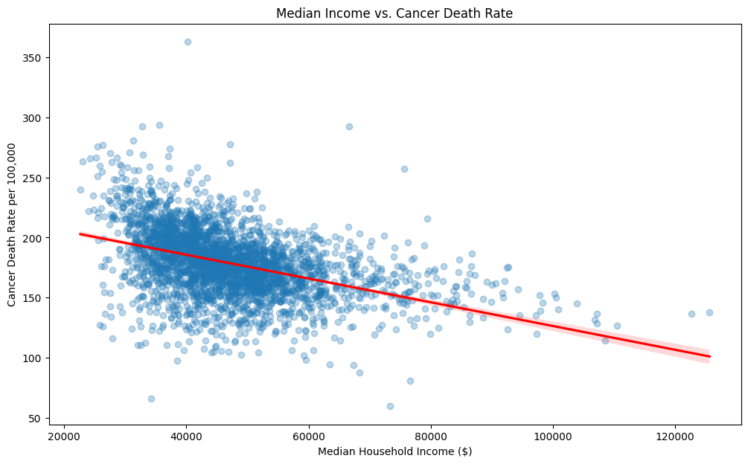
Figure 2: Correlation between Median Income and Cancer Death Rate
A similar analysis was performed to examine the impact of poverty on cancer mortality.
Figure 3: Joint Plot of Poverty Rate vs. Cancer Death Rate. This plot reinforces the findings from Figure 2, showing a positive correlation between poverty and cancer deaths. Counties with higher poverty percentages tend to experience higher mortality rates. The histograms on the top and right axes further illustrate the distribution of each variable individually.
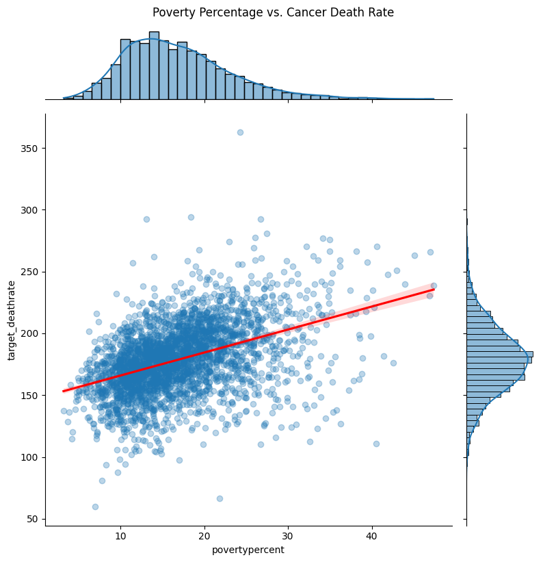
Figure 3: Joint Plot of Poverty Rate vs. Cancer Death Rate
Finally, to see this trend across discrete income groups, the average death rate was calculated for binned income brackets.
Figure 4: Average Cancer Death Rate by Income Bracket. This bar chart provides the most direct evidence of the research question. There is a clear, stepwise decrease in the average cancer death rate as the median income bracket rises. The counties in the lowest income bracket ([22k, 34k]) suffer from the highest average death rates, a trend that consistently improves with each subsequent increase in income.
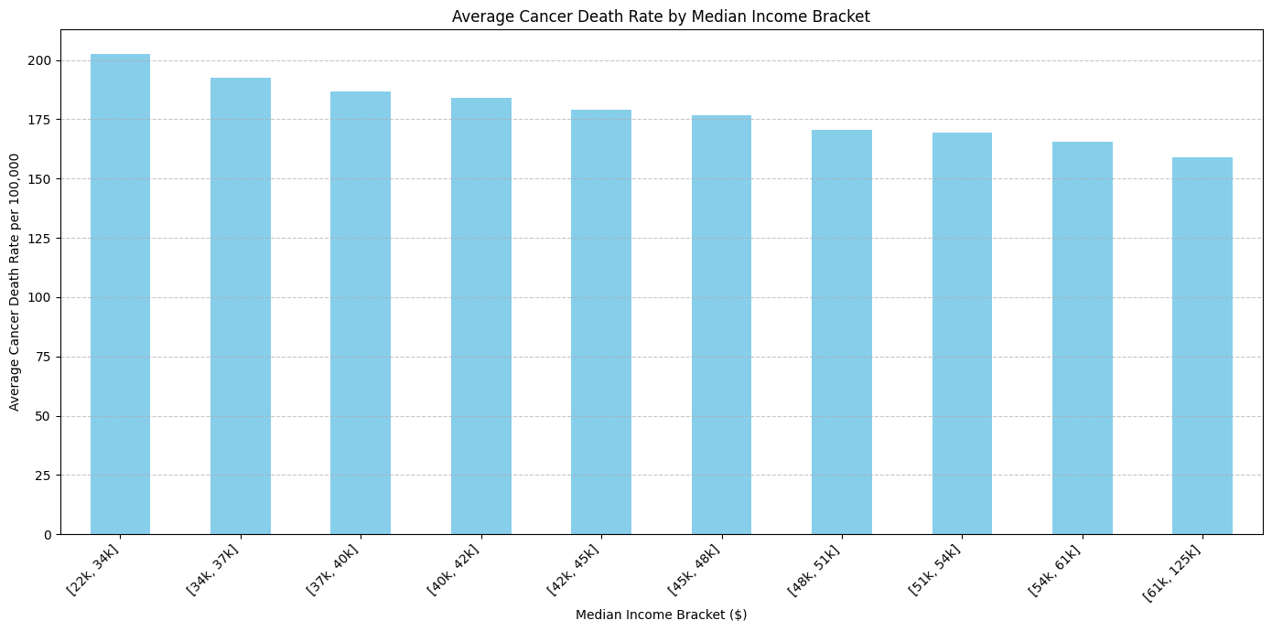
Figure 4: Average Cancer Death Rate by Income Bracket

4. Discussion
The results from this analysis consistently demonstrate that socio-economic status is a powerful correlate of cancer mortality. The inverse relationship between income and death rates, coupled with the positive relationship between poverty and death rates, paints a clear picture of health inequity.
These correlations are likely driven by a confluence of factors. Higher-income communities generally have better access to high-quality healthcare, including preventative screenings and advanced treatments. They may also benefit from better nutrition, safer living conditions, and greater health literacy. Conversely, populations experiencing poverty face systemic barriers to health, which can lead to later diagnoses, less effective treatment, and ultimately, higher mortality rates.

5. Conclusion
This research provides a clear and data-supported answer to the primary research question. Socio-economic factors are not merely associated with cancer prevalence; they are strong correlates of mortality outcomes. The visualizations derived from the analysis compellingly illustrate that as economic prosperity increases, cancer death rates decrease. This insight is critical for public health officials and policymakers, as it highlights the need for interventions that address the underlying social and economic conditions that create and perpetuate health disparities.

